**CHAPTER I**

**Introduction**

**1.1 Introduction**

The main goal of this project is to develop a cross-platform mobile application named **"*Leaf******Healer*"** focused on aiding users in recognizing plant diseases and suggesting appropriate treatment solutions. To achieve this, I use the Flutter framework that allows for creating applications for both iOS and Android platforms from a single codebase. Leaf Healer aims to provide a cohesive and efficient user experience across different devices, leveraging the framework's rich set of widgets and libraries to build a visually appealing and interactive UI.

Leaf Healer is designed to help people quickly and easily identify plant diseases just by taking a photo of the affected leaves. Once the disease is identified, the app provides users with detailed advice on how to treat and manage the problem. By using advanced technology like machine learning, Leaf Healer can accurately diagnose various plant diseases and suggest effective solutions.

**1.2 Motivation**

The idea for Leaf Healer came from seeing how challenging it can be to recognize and treat plant diseases. Many people, especially those without expert knowledge or access to professional help, struggle to diagnose plant issues correctly. As a result, plants can suffer, and crop yields can decline, leading to financial losses and food shortages.

I wanted to create a solution that makes plant care easier and more accessible. With Leaf Healer, anyone with a smartphone can identify plant diseases and get clear, practical advice on how to treat them. By using technology, I can provide valuable support to farmers, gardeners, and plant lovers everywhere, helping them to take better care of their plants.

My passion for combining technology with nature drives us to make Leaf Healer a tool that empowers people to maintain healthy plants. Whether you’re growing crops on a farm or keeping a few houseplants, Leaf Healer is designed to make plant care simpler and more effective.

**1.3 Objectives**

My project, Leaf Healer, has several key goals:

1. **Easy Disease Identification:** I want to make it simple for users to identify plant diseases. By taking a photo of a leaf, users can quickly find out what's wrong with their plant.
2. **Helpful Treatment Advice:** Once a disease is identified, Leaf Healer will provide clear and detailed instructions on how to treat it, including natural and sustainable options.
3. **User-Friendly Design:** The app will be easy to use for everyone, whether you're a beginner gardener or a seasoned farmer. We aim to make the app intuitive and accessible.
4. **Comprehensive Plant Knowledge:** The vision framework provides a large database of plant diseases and treatments so that users can find information on a wide variety of plants and issues.
5. **Continuous Improvement:** I will gather feedback from users to keep improving the app, ensuring it stays useful and up-to-date.

By achieving these objectives, I hope Leaf Healer will become a go-to resource for anyone needing help with plant care, promoting healthier plants and more sustainable practices.

**CHAPTER II**

**Procedure/ Methodology**

**2.1 Setting Up VS Code for Your Leaf Healer Project**

To start developing the Leaf Healer project using Flutter and Dart, I'll first need to install Visual Studio Code (VS Code), a powerful and popular editor for web and mobile app development. Here's how to get it set up:

**Step 1: Download and Install VS Code**

Visit the official VS Code website and download the version suitable for your operating system (Windows, macOS, or Linux).

Run the downloaded file and follow the installation instructions provided by the installer.

**Step 2: Install Flutter SDK**

Before I can start coding with Flutter, I need to install the Flutter SDK on your computer. Follow these steps:

* Go to the Flutter website and navigate to the downloads section.
* Choose the appropriate version for your operating system and download the SDK.
* Extract the downloaded zip file to a location on your computer.
* Add the bin directory of the extracted Flutter SDK to your PATH environment variable.

**Step 3: Verify Installation**

* Open a terminal or command prompt.
* Type flutter doctor and press Enter. This command checks your environment and displays a report of the status of your Flutter installation. Ensure that all recommended dependencies are installed and resolved.

**Step 4: Install Dart Plugin in VS Code**

* Open VS Code.
* Go to the Extensions view by clicking on the square icon on the sidebar or pressing Ctrl+Shift+X.
* Search for "Dart" and install the official Dart extension by Google.
* Restart VS Code if prompted.

**Step 5: Create a New Flutter Project**

* In VS Code, open the Command Palette (Ctrl+Shift+P on Windows/Linux, Cmd+Shift+P on macOS) and type "Flutter: New Project". Select it and enter a name for your project (e.g., "LeafHealer").
* Choose a location on your computer to save the project files.
* Wait for VS Code to generate the basic structure of your Flutter project.

**2.2 How Does Mobile App Work?**

In mobile application development, the Model-View-Controller (MVC) design pattern plays a pivotal role, in orchestrating the structure and interactions within the app:

**Model**: Represents the data handled by the application. For instance, in a mobile app, the Model might encapsulate user information, posts, or any relevant data fetched or stored by the app, often retrieved from databases or API responses.

**View**: Presents the visual elements and user interface to the user. In a mobile app, Views consist of the interface elements like buttons, labels, or any other components displayed on the screen. The View is where the data from the Model is displayed, and it is controlled and manipulated by the Controller.

**Controller**: Manages the application's logic and interacts with the Model. When a user triggers an action, the Controller orchestrates the data flow, handling user input and updating or retrieving data from the Model accordingly. It governs the application's functionality and business logic.  
  
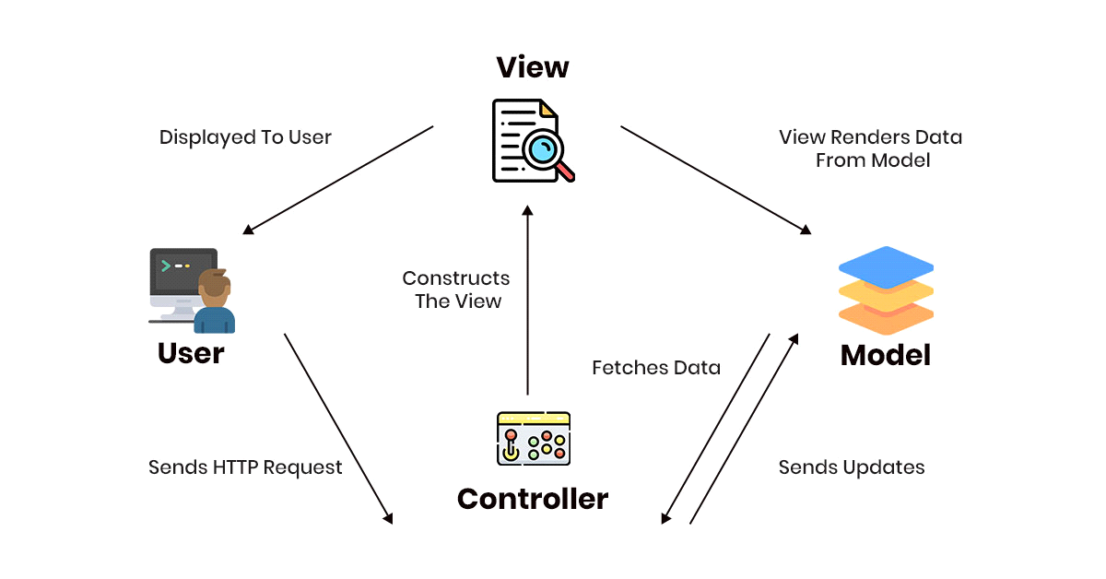

Fig – 2.1: MVC Pattern

**2.3 How to Get Started**

Leaf Healer is developed using the Flutter framework, which allows for the creation of cross-platform applications for iOS and Android. To kickstart your project, I'll need to gather some essential tools and components. Here's a step-by-step guide to setting up and beginning your Leaf Healer project:

**Prerequisites**

* Flutter SDK: Install the Flutter SDK on your machine. You can download it from the official Flutter website. Follow the installation instructions specific to your operating system.
* Dart: Since Flutter uses Dart as its programming language, ensure Dart is installed and properly configured on your system.
* Git: Have Git installed for version control. It's crucial for managing your project's codebase, especially if you're collaborating with others.
* Visual Studio Code (VS Code): Install VS Code, a lightweight but powerful source code editor that runs on your desktop.

**2.4 Developing Leaf Healer**

* **Project Structure:** Familiarize myself with the project structure created by Flutter. The lib directory contains your Dart source code, including the main.dart file, which is the entry point of your app.
* **Coding:** Start writing the Dart code. Implement the functionality for identifying plant diseases, displaying information, and integrating any external APIs or databases needed for Leaf Healer.
* **UI Design:** I use Flutter's widget library to design the user interface. Flutter's hot reload feature allows you to see changes in real time without restarting your app.
* **Testing:** Regularly test my app on both iOS and Android emulators or physical devices to ensure compatibility and performance.

When my app is ready for release, I prepare it for deployment by configuring the necessary settings for iOS and Android platforms. For iOS, I need to set up an Apple Developer account and configure my app's signing and provisioning profiles. For Android, ensure I have an Android developer account and configure your app's manifest and signing keys.

**2.5** **ER Diagram:**

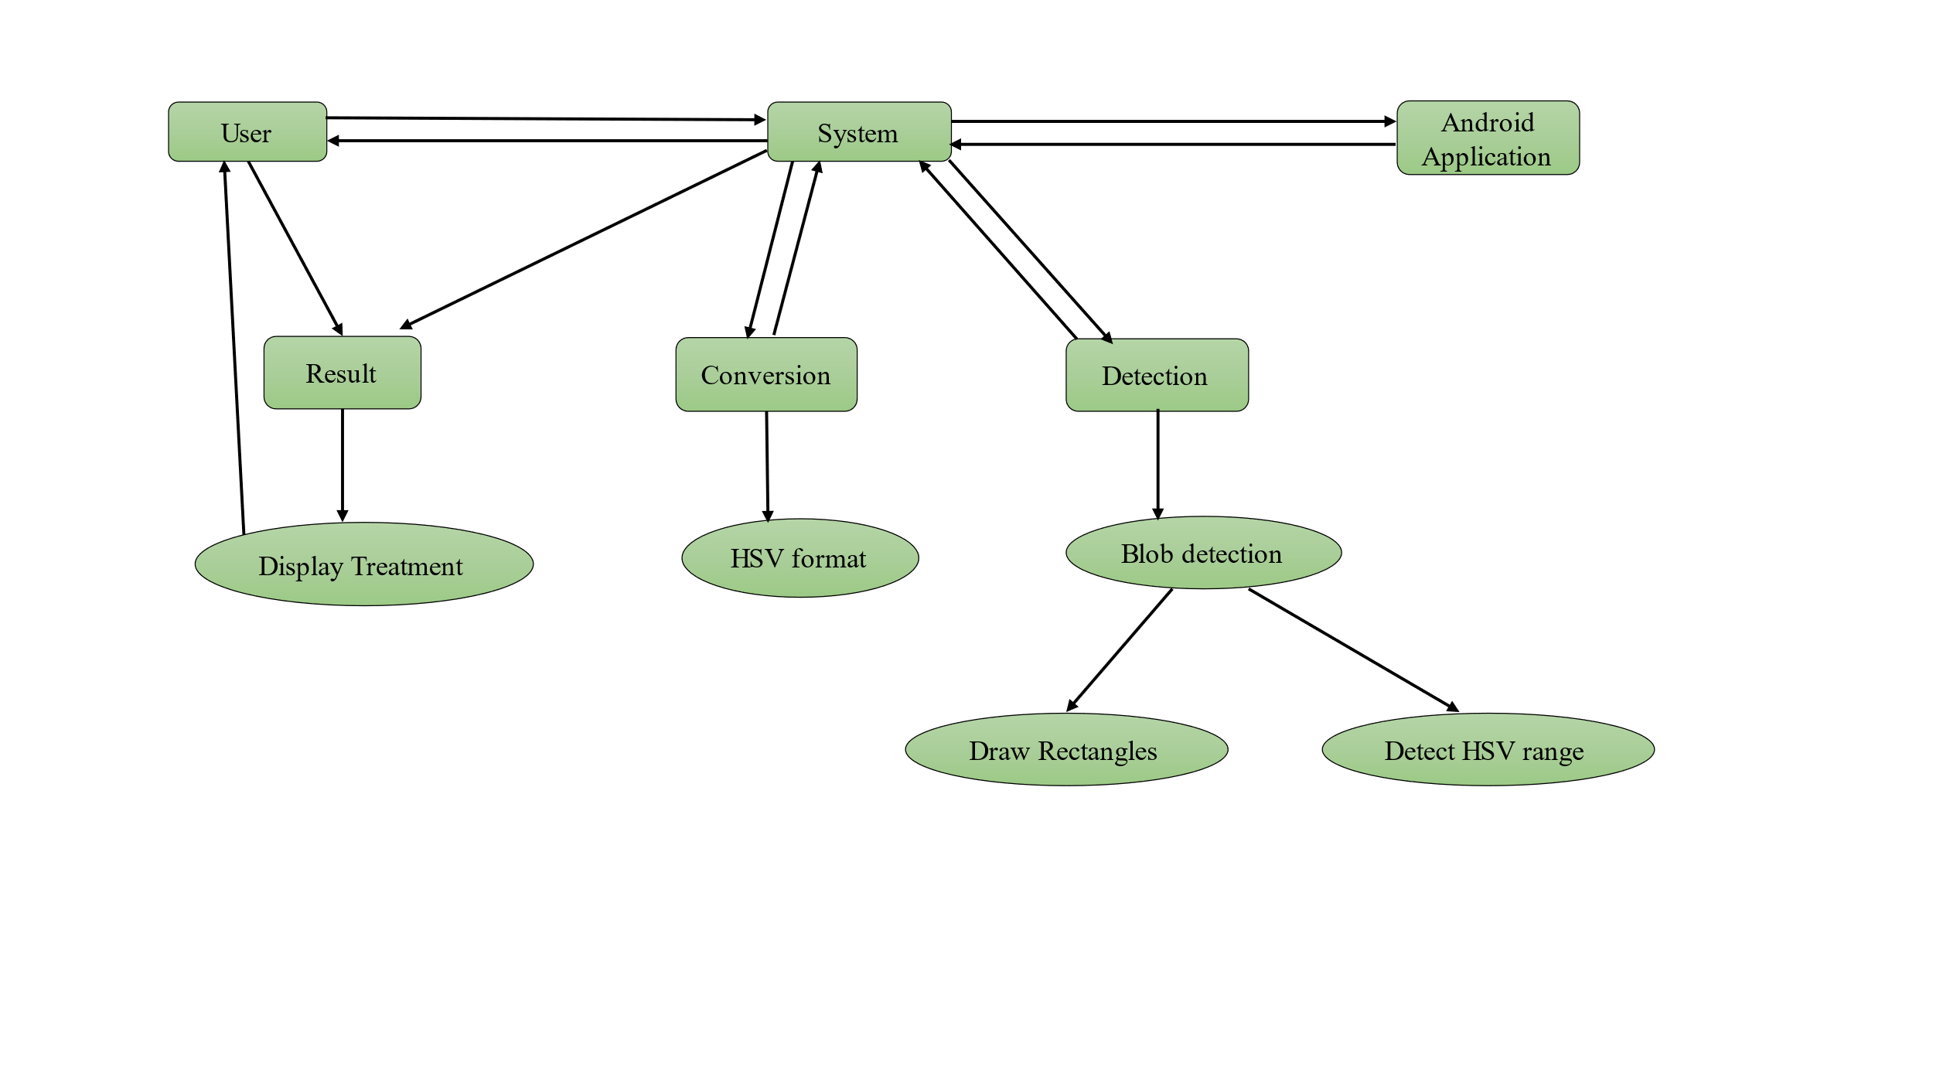

Fig – 2.2: ER Diagram

The diagram appears to be a flowchart rather than an Entity-Relationship (ER) diagram. It describes a process involving a user, system, and Android application for image processing and result display. Here's a detailed description of the flow:

**User:** Interacts with the system and views the result.

**System:** Acts as the central processing unit, interacting with both the user and the mobile application.The system is responsible for:

* **Conversion:** Converts the image into HSV format.
* **Detection:** Performs blob detection, which includes:
* **Draw Rectangles:** Drawing rectangles around detected blobs.
* **Detect HSV range:** Identifying the HSV range of the blobs.

**Mobile Application:** Interfaces with the system for image processing tasks.

**Result:** The system provides results based on the detection and conversion processes.These results are sent back to the user and also used to display treatment options.

**Display Treatment:** Shows the treatment options based on the results provided by the system.

The flowchart outlines the interactions between the user, system, and mobile application, detailing how an image is processed and detected, and results are displayed along with potential treatments.

**2.6 Workflow Diagram:**

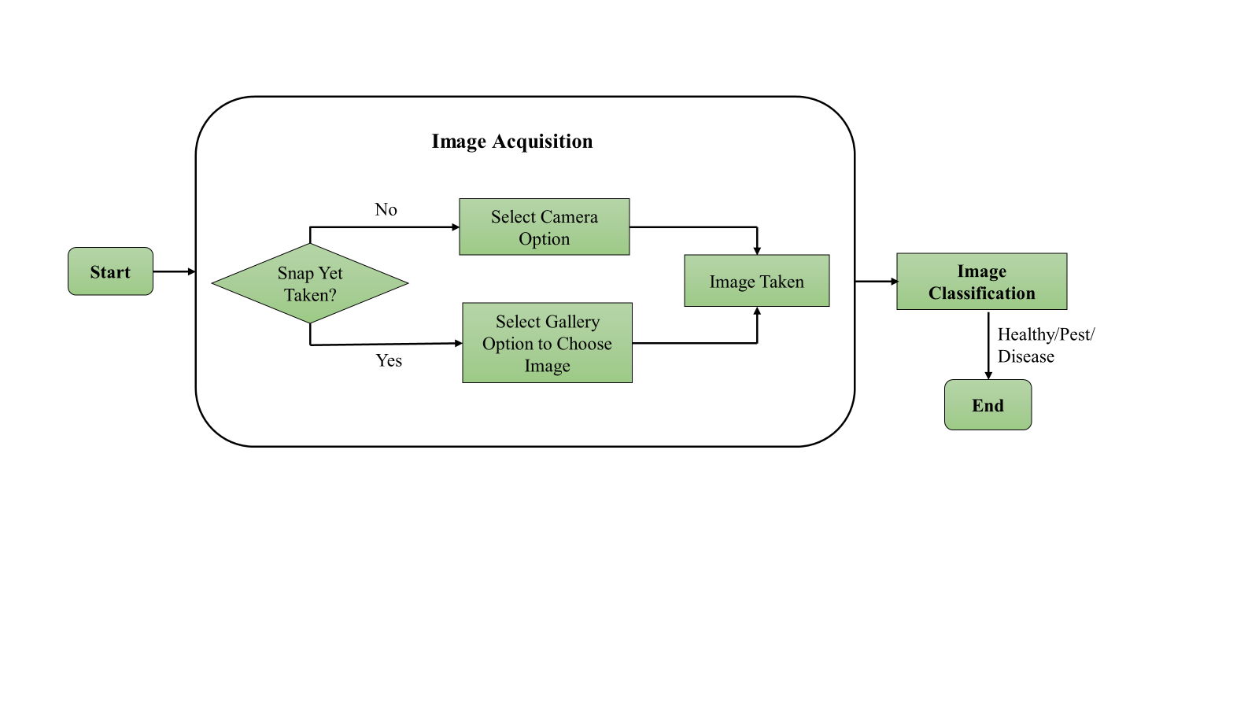

Fig – 2.3: Workflow Diagram

The flowchart depicts the process of image acquisition and classification, specifically for identifying whether an image shows a healthy state, pest presence, or disease. Here's a detailed description of the flow:

**Start:** The process begins with the start node.

**Image Acquisition:**

**Snap Yet Taken?:** A decision point to check if an image has already been taken.

* **If No:**
* **Select Camera Option:** The user can choose the camera option to take a new image.
* **Image Taken:** Once the image is captured, it proceeds to the next step.
* **If Yes:**
* **Select Gallery Option to Choose Image:** The user can choose an image from the gallery.
* **Image Taken:** Once an image is selected from the gallery, it proceeds to the next step.

**Image Classification**: The acquired image is classified to determine its condition. The result of the classification can be:

* Healthy
* Pest
* Disease

**End:** The process concludes with the end node after classification.

This flowchart outlines a clear and structured pathway for acquiring an image and classifying its condition.

**2.7 Activity Diagram:**

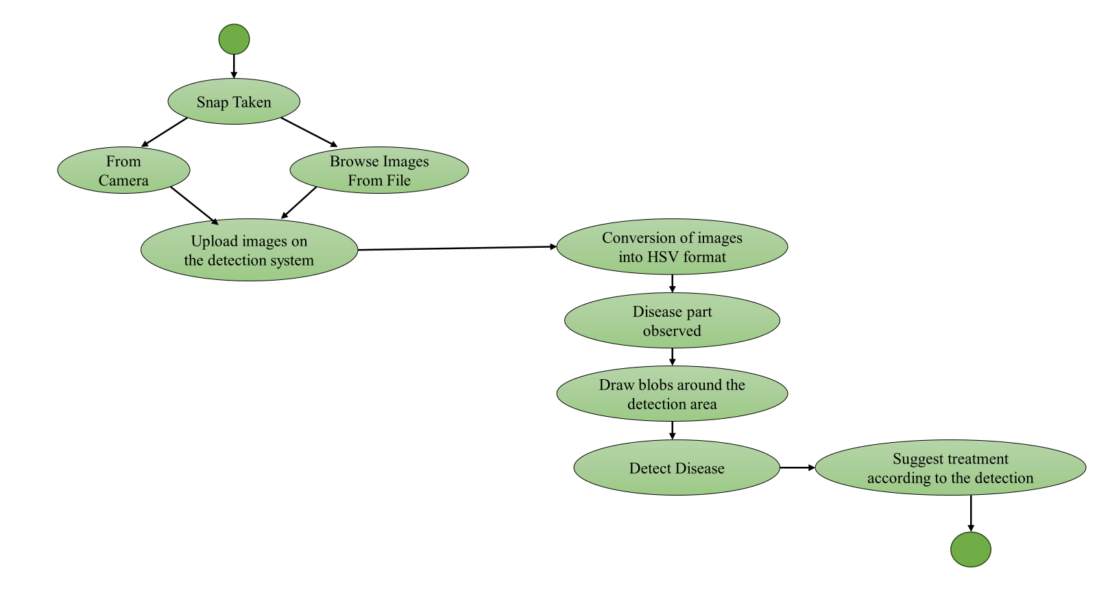

Fig – 2.4: Activity Diagram

The activity diagram illustrates the process of detecting disease in images, from image acquisition to suggesting treatment. Here's a detailed description of the activities and their flow:

**Start:** The process begins at the start node (indicated by the green circle).

**Snap Taken:** The user takes a snapshot, which can be done in two ways:

* **From Camera:** Capturing an image using the camera.
* **Browse Images From File:** Selecting an image from existing files.

**Upload Images on the Detection System:** The captured or selected image is uploaded to the detection system for further processing.

**Conversion of Images into HSV Format:** The uploaded image is converted into HSV (Hue, Saturation, Value) format, which is typically used for easier image analysis and processing.

**Disease Part Observed:** The system analyzes the HSV image to identify and observe any parts that may indicate disease.

**Draw Blobs Around the Detection Area:** Blobs (indicative shapes or areas) are drawn around the detected regions that show signs of disease.

**Detect Disease:** The system detects the specific disease based on the observed blobs and their characteristics.

**Suggest Treatment According to the Detection:** Based on the detected disease, the system suggests appropriate treatments.

**End:** The process concludes at the end node (indicated by the green circle).

This activity diagram outlines a step-by-step process for detecting disease in images and suggesting corresponding treatments, highlighting the flow from image acquisition to disease detection and treatment recommendation.

**CHAPTER III**

**Results and Discussion**

**Project Overview**

The overview of the “Leaf Healer” mobile application is described below. This project is divided into two main parts: the client side, which focuses on the user interface (UI) and user experience (UX) of the mobile application, and the backend side, which handles data processing, storage, and machine learning operations. I will discuss each section of the project, its purpose, and its functionality.

**Client-Side (Mobile Application UI)**

The client-side of the Leaf Healer application is designed to be user-friendly and intuitive, allowing users to easily interact with the app to identify and manage plant diseases. Key features include:

* **Image Capture and Upload**: Users can take photos of plant leaves directly within the app or upload existing images from their device.
* **Disease Diagnosis Interface**: After capturing or uploading an image, users receive instant feedback on the potential disease affecting their plant.
* **Treatment Recommendations:** The app provides detailed advice and steps for treating the identified plant disease.
* **User-Friendly Navigation**: The interface is designed to be easy to navigate, with clear buttons and menus guiding the user through the process.

The client side focuses on delivering a seamless experience, making it accessible to both novice and experienced users.

**Backend-Side (Server and Machine Learning)**

The back end of the Leaf Healer application is where the core functionalities and data processing occur. This includes:

* **Image Processing and Analysis**: Uploaded images are sent to the server, where they are processed using machine-learning models to identify the disease.
* **Machine Learning Models**: The app uses trained models named vision to analyze patterns in the images and match them to known plant diseases.
* **Data Management**: A robust database stores information about various plant diseases, symptoms, and treatment methods, ensuring quick and reliable access to this data.
* **Feedback and Improvement**: User interactions and diagnostic results are analyzed to continuously improve the accuracy and efficiency of the machine learning models.

The back end ensures that the application provides accurate and timely disease identification and treatment recommendations, leveraging advanced technologies to support plant health management.

**3.1 Intro Screen**

The intro section of Leaf Healer warmly welcomes users, introducing them to the app's core mission and features. It's designed to be engaging and informative, ensuring users quickly grasp the app's value in plant care. Key elements include:

* Showcases the Leaf Healer logo and a compelling tagline, guiding users to explore the app.
* Highlights the app's mission to simplify plant care through technology, catering to all levels of gardening expertise.
* Offers quick tips and tutorial videos to help new users navigate the app effectively.

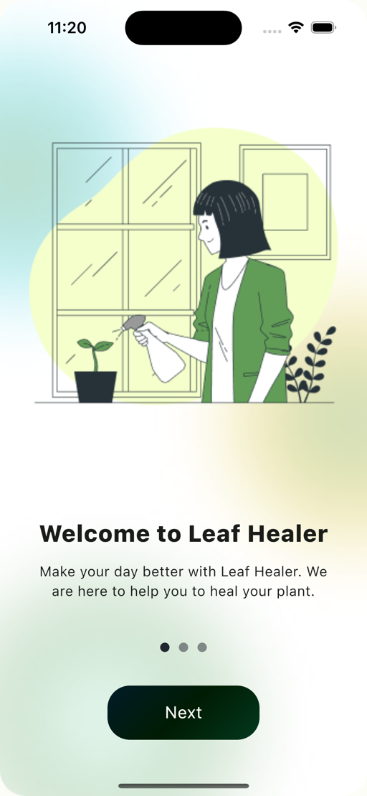 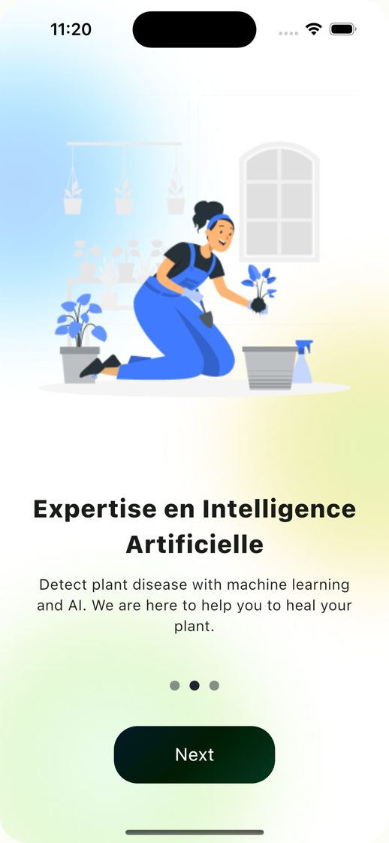

Fig – 3.1: Intro

**3.2 Home Screen**

The Home section of the Leaf Healer app is designed to be the central hub where users can easily access and manage their plant information. This section is visually appealing and user-friendly, featuring plant cards that provide a snapshot of each plant's condition. Key elements include:

* **Plant Cards**: Each card represents an individual plant with a high-resolution image, making it easy for users to identify their plants at a glance visually.
* **Plant Descriptions**: Below each plant image, a brief description provides essential details about the plant, such as its common name, scientific name, and health status.
* **Health Status Indicators**: The cards include clear indicators showing whether the plant is healthy or needs attention, using intuitive icons or color codes.

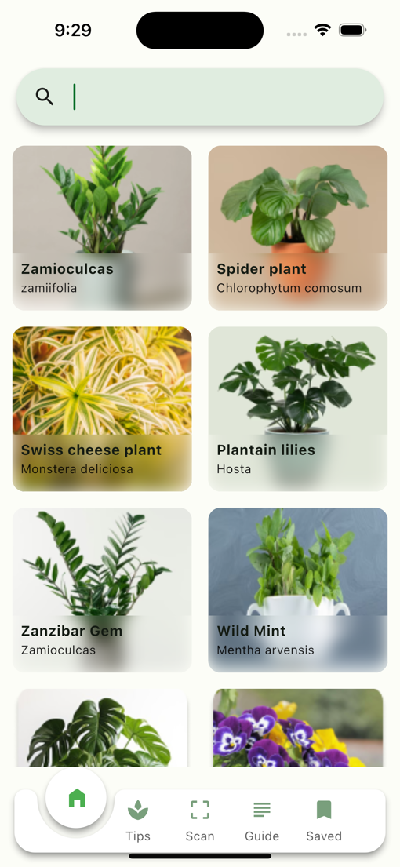 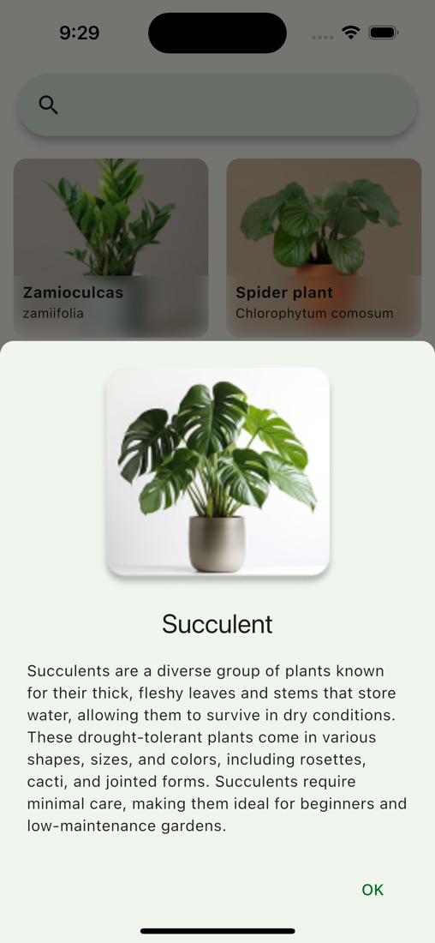

Fig – 3.2: Home

**3.3 Search Plant**

The Search Plant section of the Leaf Healer app is a powerful feature designed to help users quickly and easily find information about specific plants. Whether you're looking to diagnose a new plant issue or want to learn more about a particular species, this section provides a streamlined and intuitive way to access the data you need. Key elements include:

* **Search Bar**: A prominently placed search bar at the top of the section allows users to type in the name of the plant they are looking for. The search function supports both common names and scientific names, making it versatile for all users.
* **Auto-Suggestions**: As users begin typing, the search bar provides real-time suggestions based on the input.

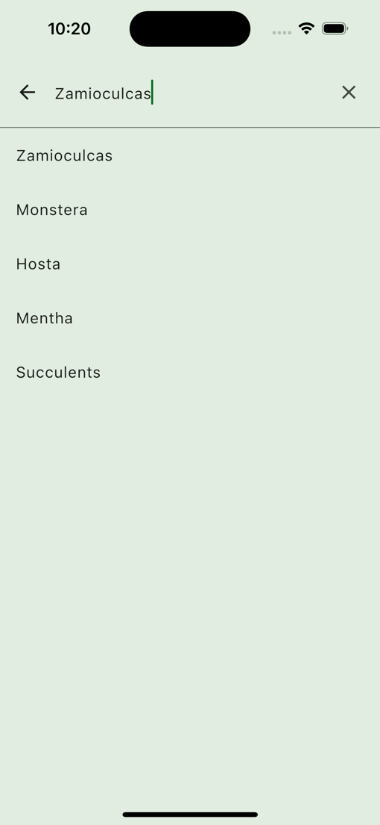 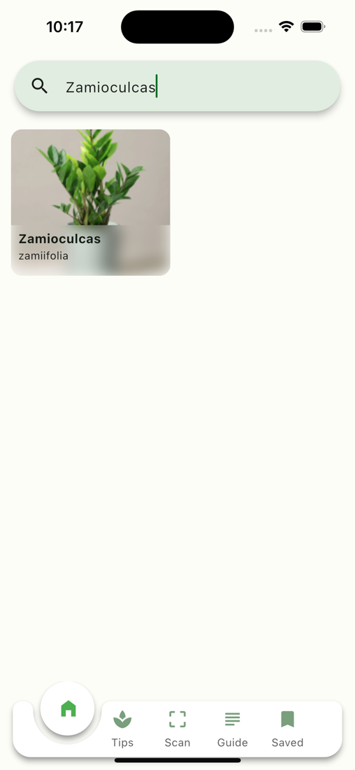

Fig – 3.3: Search Plant

**3.4 Tips**

The Tips section of the Leaf Healer app is designed to be a treasure trove of practical advice, expert insights, and helpful resources for anyone looking to improve their plant care skills. Whether you're nurturing your first houseplant or managing a thriving garden, this section offers valuable information to help you keep your plants healthy and beautiful.

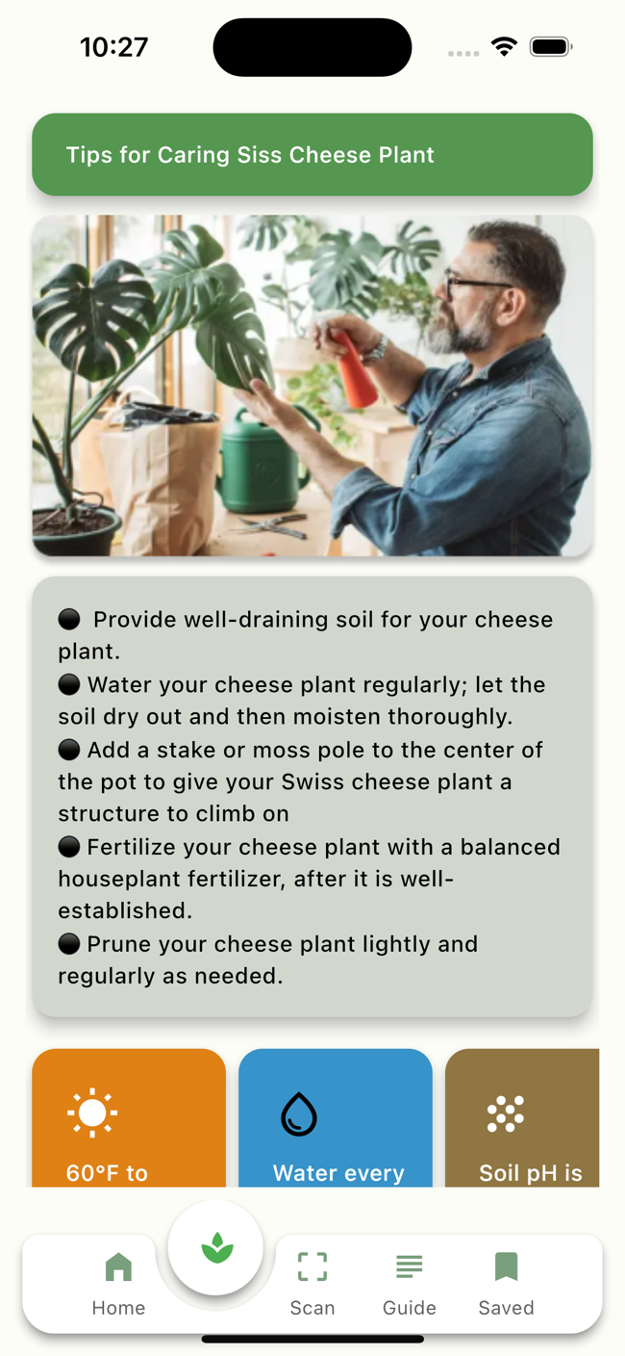

Fig – 3.4: Tips

**3.5** **Detect Disease Using Camera**

The Detect Disease Using Camera section of the Leaf Healer app is a cutting-edge feature designed to make plant disease identification quick, easy, and accurate. By leveraging advanced image recognition technology, this feature allows users to take a photo of their plant and receive immediate feedback on potential health issues and suggested remedies.

**Step-by-Step Process**

* **Open Camera Feature**: Users can access the camera function directly from the app’s home screen or navigation menu. This feature is prominently displayed for easy access, ensuring users can quickly diagnose issues as they arise.

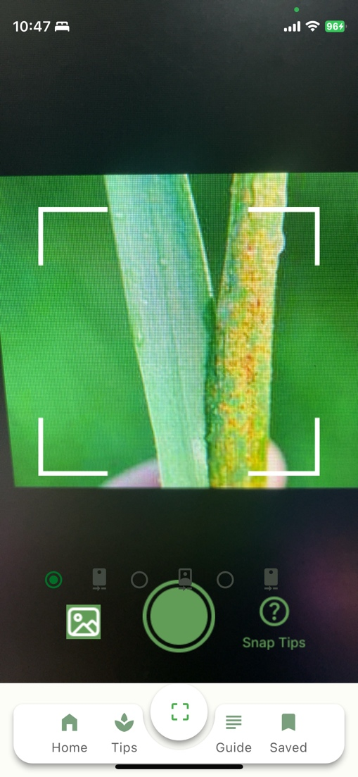 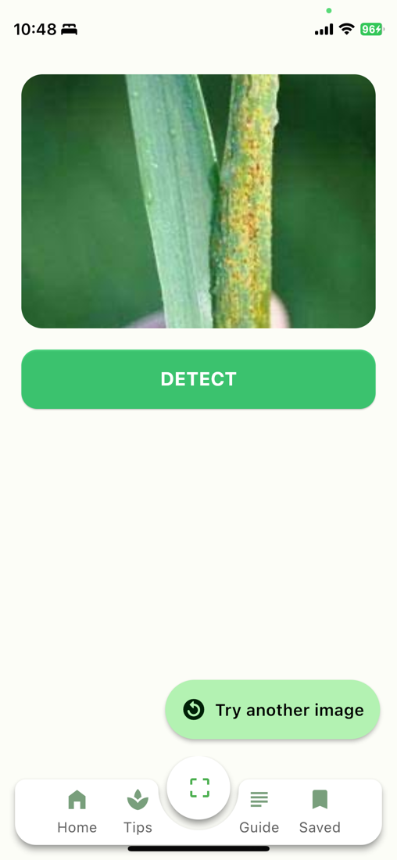

Fig – 3.5: Detect disease using camera

* **Capture Plant Image**: Using the device’s camera, users take a clear photo of the affected plant or leaf. The app provides guidelines and tips for taking a good-quality photo, such as focusing on the diseased area and ensuring good lighting.
* **Upload and Analyze**: Once the photo is captured, users can upload it for analysis. The app’s powerful image recognition algorithm scans the image to detect signs of common plant diseases, such as spots, discoloration, wilting, or unusual growths.
* **Instant Results**: The analysis is performed in real time, providing users with immediate results. The app identifies the potential disease or issue, displaying the diagnosis on the screen.

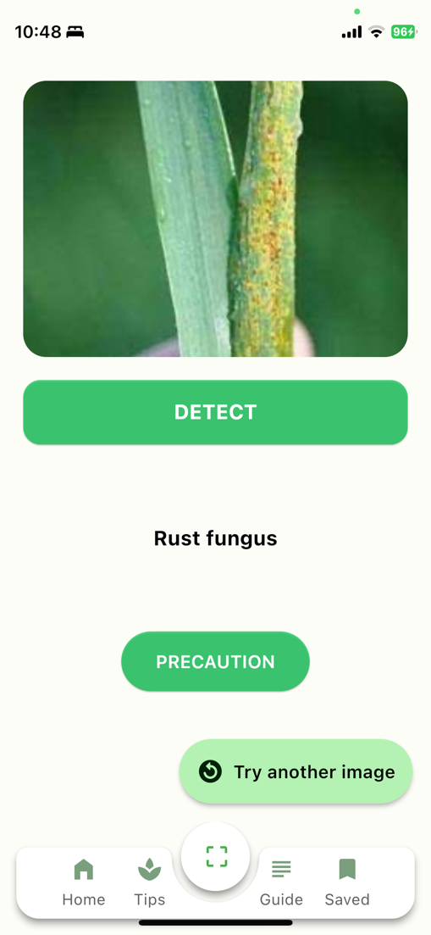 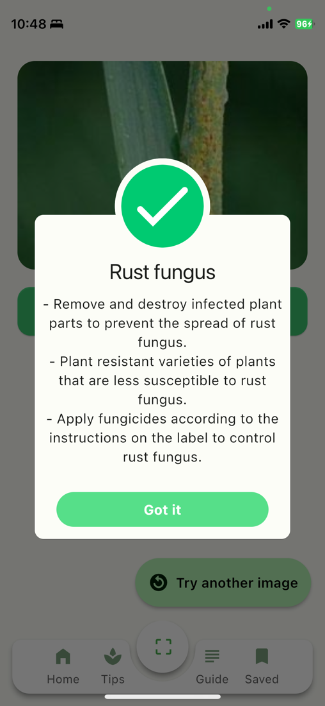

Fig – 3.6: Detect disease using camera

**3.6** **Detect Disease Using Gallery Image**

The Detect Disease Using Gallery Image section of the Leaf Healer app provides a convenient and efficient way to identify plant diseases using pre-existing photos from your device's gallery. This feature is perfect for users who have previously captured images of their plants and now seek expert analysis to diagnose and address any health issues.

**Step-by-Step Process**

* **Access Gallery Feature**: Users can easily navigate to the gallery feature from the app’s home screen or through the main navigation menu. This function is designed to be user-friendly, ensuring quick and easy access to your stored images.

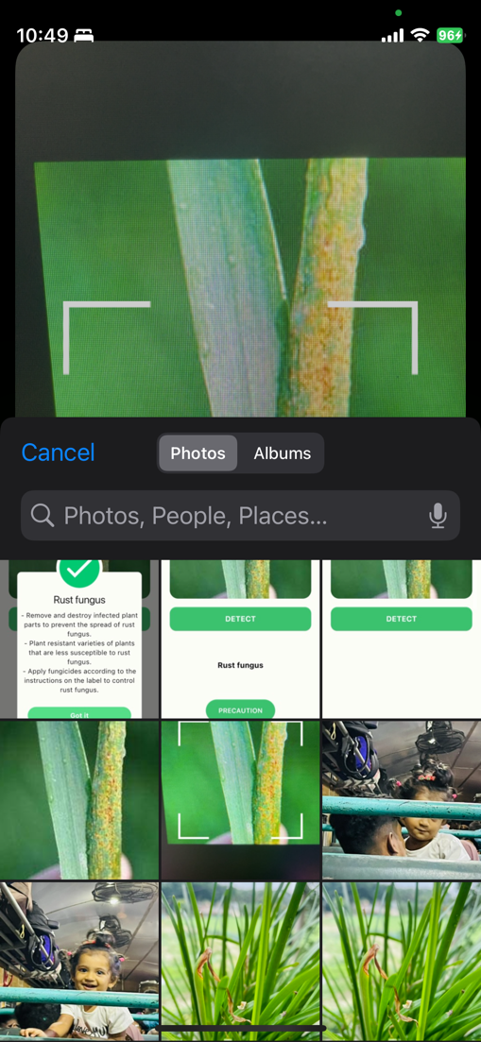 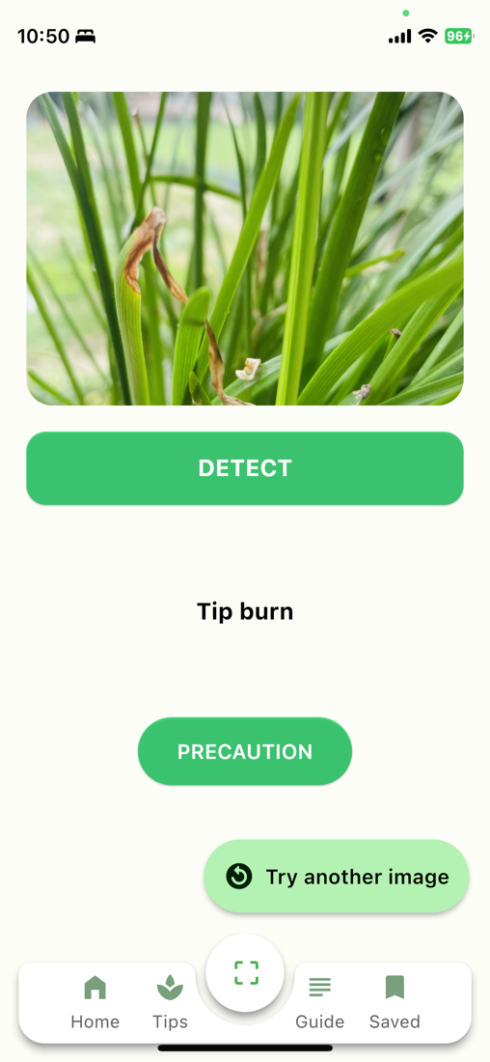

Fig – 3.7: Detect disease using gallery image

• **Select Plant Image**: Once in the gallery, users can browse through their stored photos and select an image of the plant they want to diagnose. The app supports various image formats and provides an intuitive interface for image selection.

• **Upload and Analyze**: After selecting the image, users upload it to the app for analysis. The Leaf Healer app employs advanced image recognition algorithms to scan the photo for symptoms of common plant diseases.

• **Instant Results**: The app processes the uploaded image in real time, delivering immediate diagnostic results.

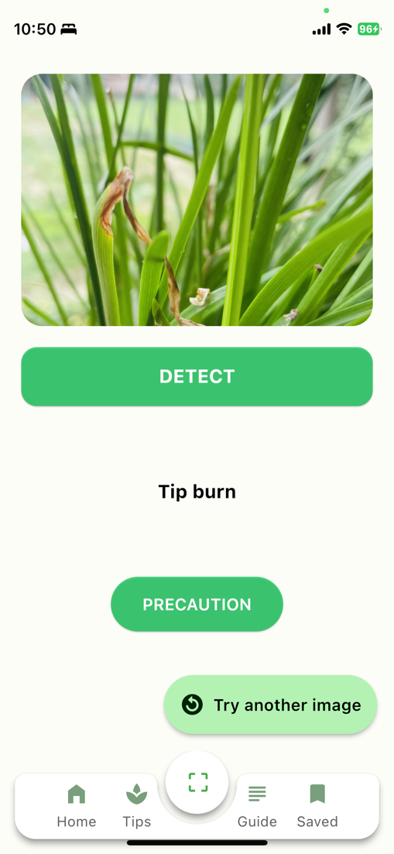 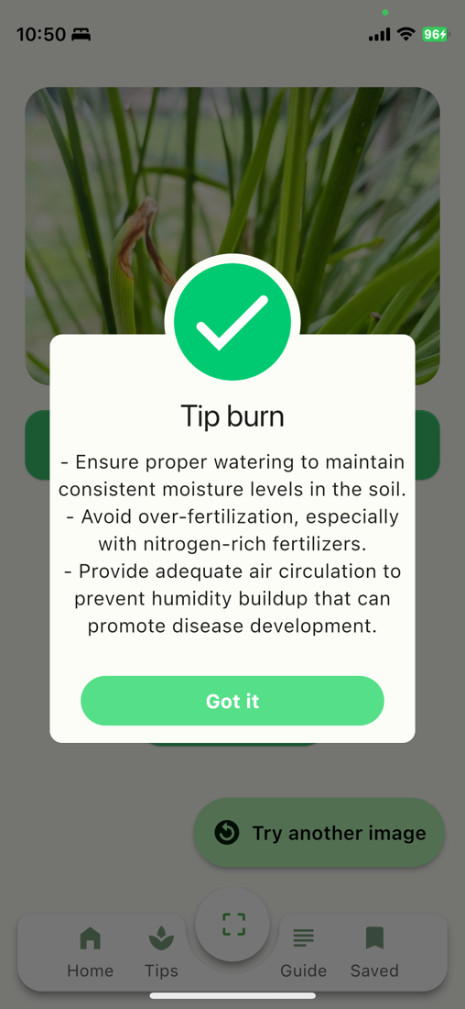

Fig – 3.8: Detect disease using camera

**3.7 Care Guide**

The Care Guide section of the Leaf Healer app is your go-to resource for detailed information on how to properly care for a wide variety of plants. This feature is designed to provide users with comprehensive, easy-to-follow instructions on maintaining plant health and vitality. Whether you're a seasoned gardener or just starting your plant journey, the Care Guide offers valuable insights tailored to your plant's specific needs. Key elements include:

* **Comprehensive Care Instructions**: Each plant profile within the Care Guide includes detailed information on watering, light requirements, soil preferences, and other essential care practices.
* **Care guide video**: Videos feature insights and advice from plant care experts. These professionals share their knowledge and best practices, providing users with valuable information on how to maintain healthy plants and address common issues.

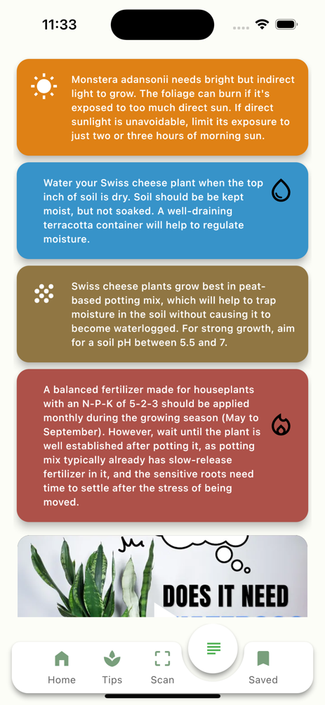 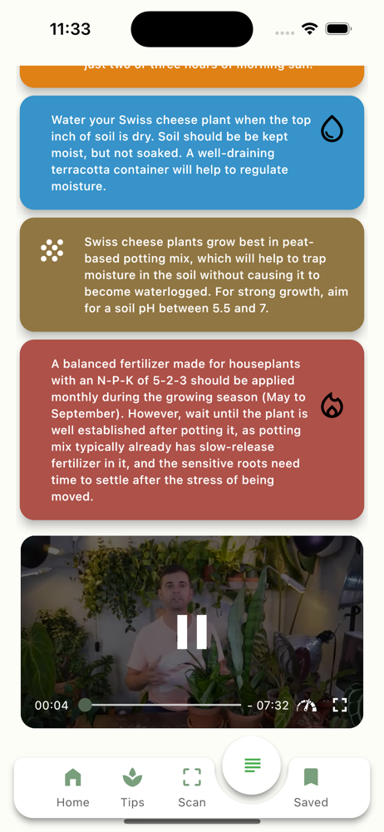

Fig – 3.9: Care Guide

**3.8** **Saved Plant**

The Saved Plant section of the Leaf Healer app serves as a personalized archive where users can store and manage detailed profiles of their plants. This feature is designed to help users keep track of their plant collection, monitor health conditions, and access customized care information. The intuitive layout and comprehensive functionality make it easy to manage and nurture each plant effectively.

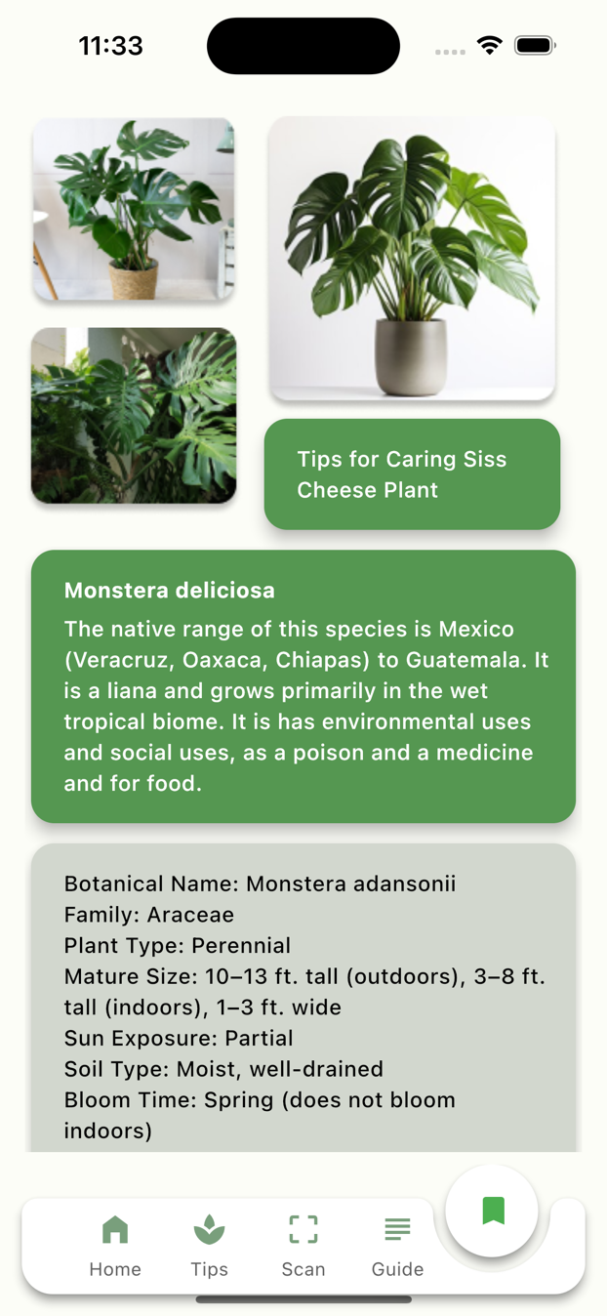

Fig – 3.10: Saved Plant

**CHAPTER IV**

**FUTURE WORK**

To continue enhancing Leaf Healer's utility and user satisfaction, several exciting updates and additions are planned. These innovations aim to expand the app's capabilities, making it an indispensable tool for anyone passionate about plant care. Here's a glimpse into what's coming:

* **Interactive Learning Modules:** Develop interactive learning modules that cover a wide range of topics related to plant care, from basic maintenance to advanced techniques. These modules will be designed to engage users and deepen their understanding of plant health.
* **Community Collaboration Features:** Expand the app's social aspects by allowing users to collaborate on projects, share insights, and learn from each other. This could include features like shared plant journals, discussion forums, and group challenges.
* **Personalized Care Plans:** Utilize user data and behavior patterns to create personalized care plans for individual plants. This will help users maintain optimal plant health with minimal effort.
* **Augmented Reality (AR) Plant Identifier:** Incorporate AR technology to allow users to identify plants simply by pointing their camera at them. This feature will be particularly useful for users who encounter unfamiliar plants.
* **Accessibility Enhancements:** Focus on making Leaf Healer more accessible to users with disabilities. This may involve text-to-speech functions, high-contrast themes, and voice commands for controlling the app.
* **Integration with Smart Home Devices**: Enable Leaf Healer to connect with smart home systems, allowing users to monitor and adjust their indoor and outdoor plant environments automatically based on the app's recommendations.
* **Subscription Services:** Offer premium subscription services that provide exclusive content, advanced features, and priority support. This will help sustain the app's development and introduce revenue streams to support ongoing improvements.

These future developments are designed to keep Leaf Healer at the forefront of plant care technology, ensuring it remains a valuable resource for users worldwide. By continuously innovating and adapting to user needs, Leaf Healer aims to foster a vibrant community of plant lovers who benefit from cutting-edge tools and knowledge.

**CHAPTER V**

**CONCLUSION**

**Conclusion**

Creating the Leaf Healer app has been an enlightening journey, significantly enriching my skills in mobile app development and user experience design. This project has not only allowed me to delve deeply into the nuances of plant care and disease identification but has also amplified my capabilities in integrating advanced technologies into practical applications.

In conclusion, Leaf Healer represents more than just an app—it symbolizes a milestone in my professional growth. This project has equipped me with new skills and insights and has deepened my passion for blending technology with real-world applications. As I move forward, the lessons learned from Leaf Healer will serve as a guiding force, fueling my ambition to create impactful and meaningful tech solutions. With the knowledge and experience gained from this journey, I am eager to tackle new challenges and continue growing as a developer and innovator.